1. 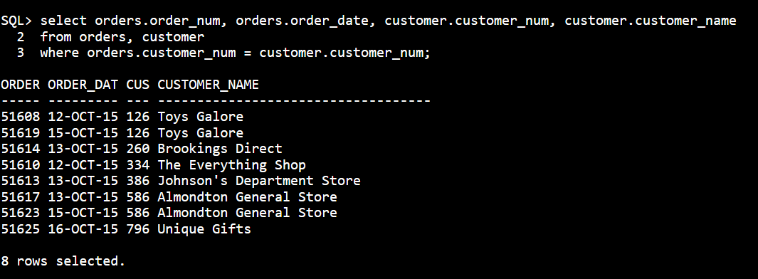For each order, list the order number and order date along with the number and name of the customer that placed the order.

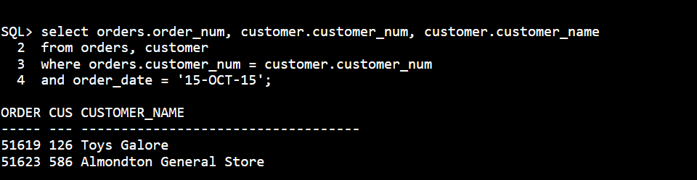2. For each order placed on October 15, 2015, list the order number along with the number and name of the customer that placed the order.

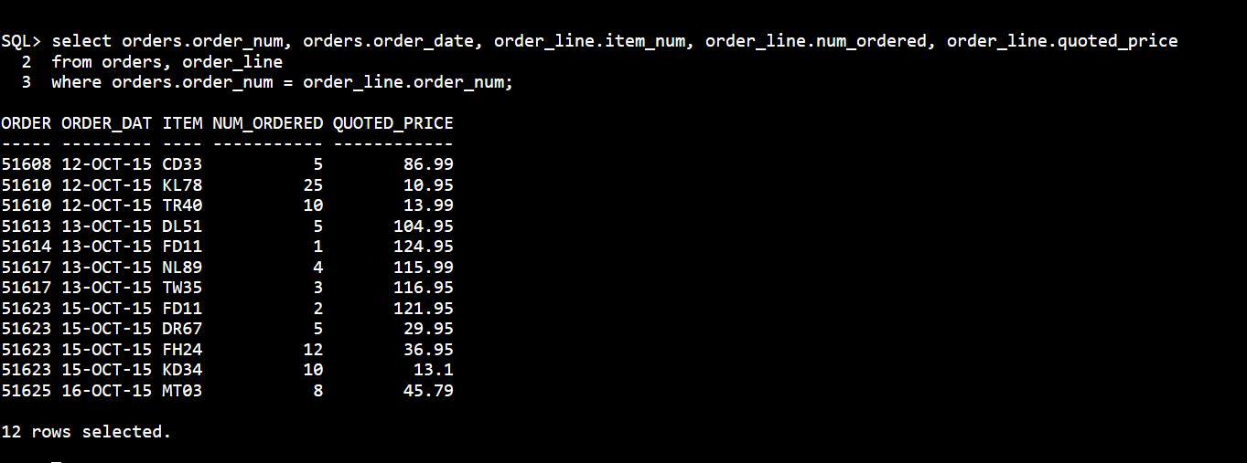3.For each order, list the order number, order date, item number, number of units ordered, and quoted price for each order line that makes up that order.

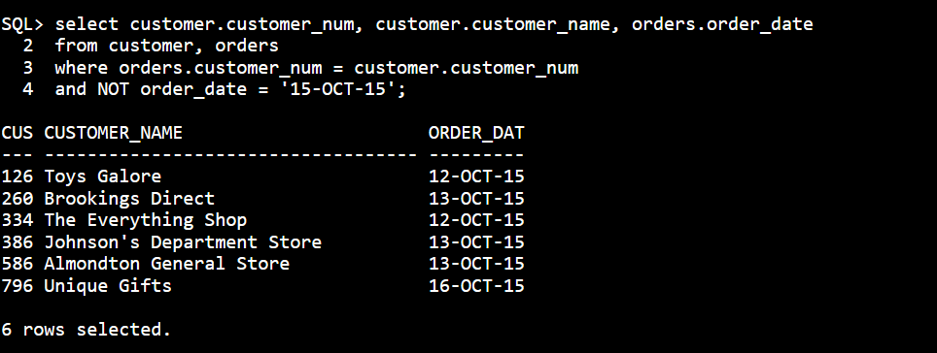6. Find the number and name of each customer that did not place an order on October 15, 2015.

7. For each order, list the order number, order date, item number, description, and category for each item that makes up the order.

